# Company Background

## Brief History

Royal Cablevision Corporation started in 1993 as a small cable company. Royal Cablevision provides cable TV service at a low price to several cities in Laguna. The company, founded by the collaborated effort of Generoso Opina and Dennis Lazaro. Today, Royal Cablevison's Technical Headquarters located in Dictado Village in Sta. Rosa, Laguna and they have more 8 branches all over the region of Laguna. Now Royal Cablevison expanded its services by providing better TV and Digital TV coverage, and personalizing of channels. In 2011, the Company has implemented their new service by providing a new broadband internet coverage.

## Products / Services

Royal Cablevision provides a range of TV and Digital TV coverage, and broadband coverage all over Laguna. Royal Cablevision provides a set services called Plans in ‘Standalone’, ‘Jade’, and ‘Diamond’ packages.

Royal Cablevision Packages:

* **Standalone –** Offers standard TV coverage throughout Laguna. Prices for Standalone TV cable vary depending on region. This package only includes TV Analog service and not Internet or Wi-Fi-Internet upgrade plans.
* **Jade –** Offers HDTV cable coverage as well as upgrades for internet and Wi-Fi Internet plans that ranges between 1000 – 4000PHP depending on bandwidth.
* **Diamond –** Offers the highest resolution HDTV cable coverage as well as upgrades for internet and Wi-Fi-Internet plans that ranges between 1000 – 5000PHP depending on bandwidth and selection of premiere channels.

## Market

Royal Cablevision caters to everybody within the Laguna region. As of today, Royal Cablevision sees cable and internet as not just luxury but a part of our daily lives. With that concept, Royal Cablevision provides to all services to all classes of society. The demographic of the company's subscribers are housewives and children.

## Organizational Chart

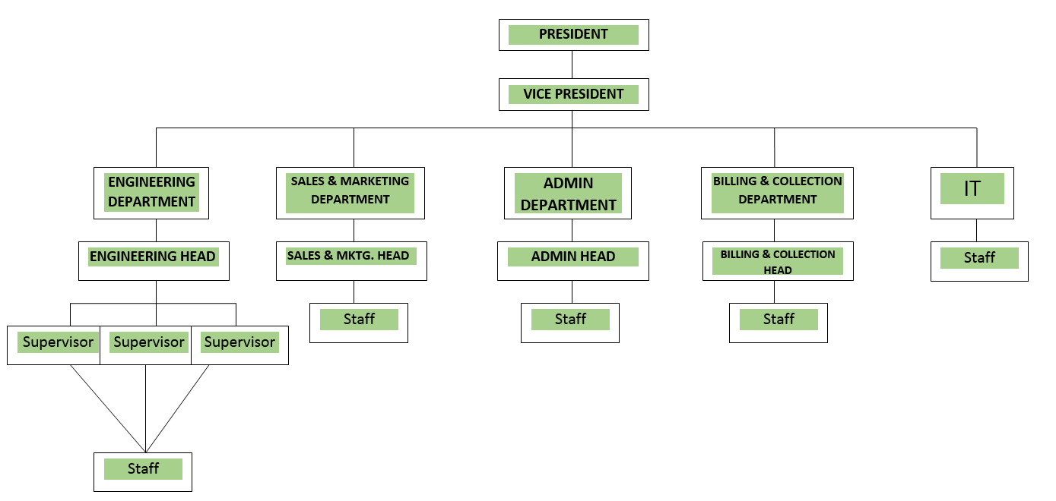

*Figure 1 – 1 Royal Cablevision’s Organizational Chart*

# Project Background

## Project Description

Due to issues with the IT Administration, and the suspension of the company's current accounting information system, a new web application is in development. The intern was tasked to create a Web Application that reflects the company's Accounting Information System (AIS). The Web Application will help Employees gain access to customer and billing information. The Web application integrated with Royal Cablevision’s Website will help organize outgoing billing information. This information will be useful for employees to analyze and manipulate customer’s data for customers to track.

The company uses social networking sites such as Facebook to disseminate company information. This method of communication degrades the validity of the company. An Official website, created by the Intern, will help customers by providing accurate information about their subscriptions and billing information. The website will also provide new customers the ability to subscribe.

## Significance of the Project

* + 1. Academe

The project is significant to the academe because the project promotes those who studies in the field of Information Technology. Web Applications, Information and database management are skills students will apply in real life. Students will be able enhance these skills and further enhance their knowledge of IT. This project will provide several opportunities such as internships, training for all IT-related students. The University can collaborate with the company for future academe partnerships and On-the-Job-Training connections. This collaboration will create a venue for promotion of the University. The university can implement such knowledge to the IT-curriculum for future research.

* + 1. Student

The project is significant for the student because it allows the student to grasp hands on experience and training. The student will be able to develop skills that apply only in a working environment. The student will able to handle important information, and tackle real world problems. The student will be able to adapt to IT-related crises as well as develop solutions to prevent future incidents. The project will allow the student to contribute to the company and provide them with a platform to work with.

* + 1. Society

The one of the company’s Core Values is Trust. With the implementation of the AIS Web application and the Official Web site, the customer will be able to trust their cable company to take care of their information. The company will have a digital presence for customers to rely on and provide information and guidance. Subscribers will have access to their billing information, and eliminate the fear of paying too much for TV and internet coverage.

## Scope and Limitations

The activities of the intern revolves around monitoring the company's Accounting Information System (AIS). The intern's assignment is to provide assistance to the IT Department of Royal Cablevision. This assignment focuses on development of a Web Application that uses open source tools. The Intern can only access company information limited to the following;

* Acquiring data from the previous AIS web application for migration processing.
* Update and Create new Customer information and billing information for the prototype.

The Intern’s task was to create a prototype web application similar to the Company’s AIS. The intern is only limited to following requirements;

* Creating new bills for customers.
* The ability to update bills for the sake of error-handling
* Registering Customers into the system.
* The ability to delete bills from the customer’s billing history.

**Table 4 – 2**, under **Functional Requirements** explains in detail, the requirements of the web application. Refer to **chapter** **4.2 functional Requirements** for an extend view of the requirements.

The intern’s second task was to create a Company Web Site for Royal Cablevision. The intern is only limited to following requirements;

* Only new customers to subscribe.
* Allow customers to view their billing history.
* Inform customers of their subscription status.

**Table 4 – 3**, under **Functional Requirements** explains in detail, the requirements of the web application. Refer to **chapter** **4.2 functional Requirements** for an extend view of the requirements.

The intern was requested to create a User Manual for a Web Application prototype for an Accounting Information System & Official Royal Cablevision Website.

## Student’s Role

The role of the intern was to analyze Company’s current accounting Information System in order to develop a web application. The intern will integrate the Web Application with the company’s new website. The intern will produce a user manual for the AIS Web Application.

# Methodology

## Phases/Activities

Enquire

Launch

Theorize

Execute

Test

*Figure 3 – 1 Royal Cablevision Methodology*

Figure 3 – 1 shows the Royal Cablevision’s Methodology for Development.

* + 1. Enquire

In this phase, the intern was given a checklist of development tools that is needed for developing the Web Application. Each tool was installed manually and the instructions for installing such tools could be found online. Such tools consist of Apache 2.2, MySQL Workbench (MySQL tools from Oracle), and Sublime Text 2 (trial version).

While installing MySQL workbench, the service port needed port configuration. Port: 3306 was configured for the web application prototype to work. Port: 3247 was reserved for the company's current Accounting Information System.

The intern had to manually install Apache 2.28 in the Directory files of MySQL so that the PHP tools could function correctly. The intern was also instructed to install certain programming tools that the company provided in order to use the new Accounting Information System. Such tools required a license to use such as Visual Studio 2012, SQL Server Management Studio 2010, and ESF Database Migration Toolkit.

The IT admin required the intern to install trial versions of both the Visual studio and SQL server management studio. The intern can only view Accounting Information System through the Visual Studio Terminal. By viewing the current system, the intern was instructed to migrate data that would be useful to develop the prototype. The intern reported to both the Marketing & Sales department and the IT Department. The intern was briefed about the assignments regarding the Web Application prototype and company's Website.

* + 1. Theorize

A great amount of time was spent on studying the previous development of the Accounting Information System. The Intern took the information gathered from Accounting Information System and began to brainstorm. This led to in-depth research of database design and learning several languages left by the previous employee. The intern researched on current development of Web Applications and Accounting Information Systems. Using the tools from the previous system, the Intern drew many diagrams to illustrate the functions of the prototype.

Most of the materials needed for the prototype were acquired on the web. All data from the previous system was migrated and uploaded to a MySQL platform. However, for the intern to develop a web application, the intern was only limited to use data pertaining to customers, services and billing information. Even the data acquired by the intern were limited and the intern will have create new tables in order replace restricted ones. The intern spend more time conceptualizing with the IT Staff on solutions and developed new tools to use in the process. By analyzing the system, the intern has established many project goals for the new web application.

* + 1. Execute

In this phase, the intern, alongside the IT staff, started the development process of the prototype. The IT staff worked on the accounting information system modules not mention in Table 4-2 under Functional Requirements. The intern created separate portals for both the Employees and the customers. The intern focused on the Employee side, to ensure the functions that were mentioned Table 4-2 were met. There were no interruptions of implementation for Employees except for the deletion of customers. The admin wanted the option available but not functional due issues with the migration process.

The intern focused on developing the Company website. There were several changes in the design of the website. Some were mentioned by the Marketing & Sales Department, other changes were made by the Operations Management. The option for allowing customers to change subscriptions was put on hold due several interferences with the migration process.

* + 1. Test

In preparation for the project deadline, the intern left time in for testing the modules of the Web Application. There were several errors on how the data would be represented. Some of the search modules needed fixing in order to meet the employees use. The intern coded the functions mention in **chapter** **4.2 functional Requirements.**  Most of the errors that were present were MySQL value type errors. See **chapter 4.4.6 Tests Scripts** to view the test procedures used by the intern.

* + 1. Launch

Due to time constraints the intern’s Web Application was put on hold. The Operations management has not come to a decision to develop Web application and integrate it with the Website. The either has two choices to decide be launching their Site.

One option is to implement the project and integrate the Web Application prototype with the company website. The second option is use the tools provided by web-hosting companies such as HostGator.com. The material used in in developing the prototype will transfer to HostGator's web interface. The only issue with the second option is that the company will not be using Bootstrap as their styling format. The company will only use the styling sheets provided by HostGator.

## Inputs

Manuscripts of database design left by previous employees help the Intern understand the concept of the current Accounting Information System. Reference of programming manuals of Visual Studio 2008-2012 helped in familiarizing with the code. Seminars and orientation help the intern understand the company policies and create a better working atmosphere. IT staff assisted in some of the networking modules not specified for the intern’s project.

## Tools Used

The intern’s main focus was to accomplish the project using open source beta version tools such as MySQL 5.6 for the database, Apache 2.28 for PHP, Bootstrap 3.1.1 for the styling the UI and sublime Text 2 or Notepad++.

Sublime Text 2

Sublime Text is a cross-platform text/ source code editor, Sublime Text is proprietary software that is extendable with plugins source editing to other text-based applications. Most of Sublime Text’s extending packages have free-software licenses and are community-built and maintained.

MySQL 5.6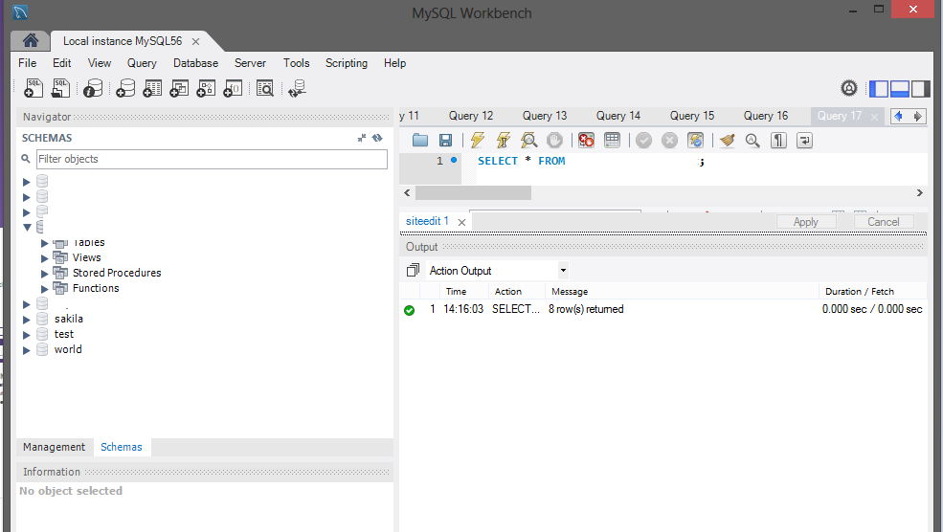

*Figure 3 – 2 MySQL 5.6 Workbench*

MySQL is a popular open Source relational database management system that runs the server providing access to a number databases. MySQL, because of their system be open source has no limitation to the range of application that this system is used for. Such applications are, e-commerce, data warehousing, web databases, distribution application and logging applications.

Bootstrap 3.1.1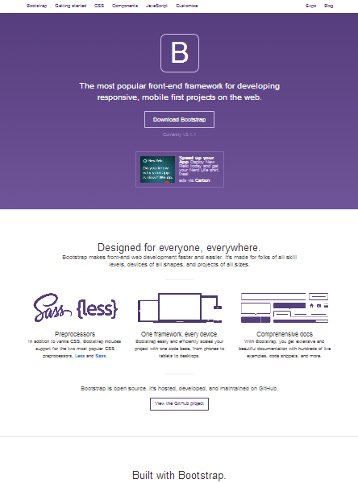

*Figure 3 – 3 Bootstrap reference home page*

Bootstrap is an Open Source Web Development Framework used for structuring Webpages. The Framework is consisted of ready-to-use Cascading Style Sheets (CSS) as well JavaScript snippets to help style webpages easily and conveniently. Only the use of classes selected for the bootstrap.css was required in order to use the classes provided by bootstrap.

Apache 2.2

Apache is a web server software that is used to create dynamic and static web pages on the World Wide Web. Apache is to accomplish many of the server tasks and serves a communicator for any database management system

PHP

PHP, also known as Hypertext Processor, is a scripting language that was designed for web development to create dynamic Web Pages PHP code is interpreted by a server, which generates the results in a web page: PHP commands can be embedded directly into an HTML source document.

Visual Studio 2012

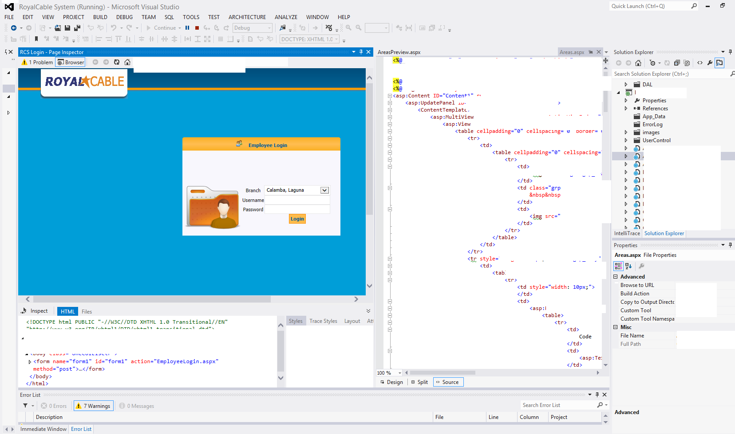

*Figure 3 – 4 Visual Studio 2012 Workstation at Royal Cablevision*

Visual Studio is High level Integrated Development Environment or IDE made by Microsoft. Visual Studio is used to develop computer programs for Microsoft Windows as well as develop Web Applications and Web Services. Visual studio is also considered a code editor, integrated debugger works both as a source-level debugger and a machine-level debugger. Built-in languages include C/C++ (Visual C++), VB.NET (Visual Basic .NET), C# (Visual C#), and F# (Visual Studio 2010).

SQL Server Management 2010 (**Microsoft SQL Server**)

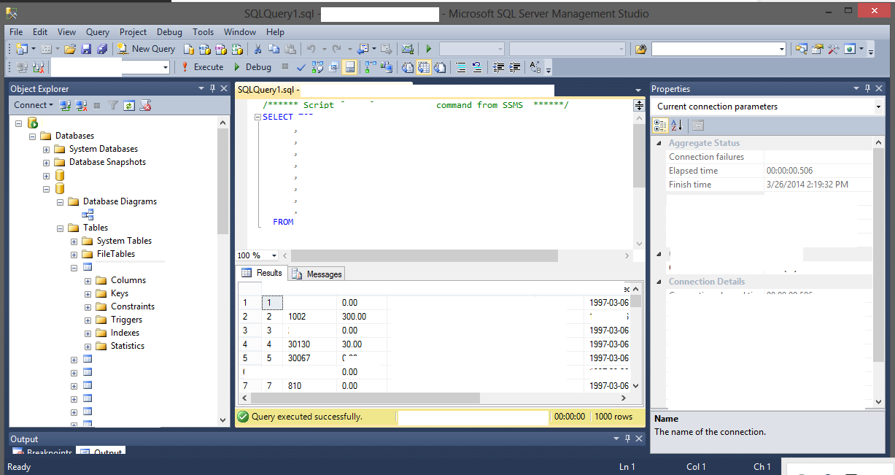

*Figure 3 – 5 Microsoft SQL Server*

Microsoft SQL Server is a relational database management system developed by Microsoft. It’s no difference from MySQL, accept that Microsoft SQL Server (MSSQL) is licensed software and its runs under the .NET Framework series of Microsoft. Microsoft SQL Server requires a lot of extensible plugins in order for the MSSQL system run various languages not created by Microsoft.

## Output

The expect output of the project includes the following:

* Accounting Information System Web Application
  + The Web Application that was assigned to the Intern to create as form submission a completion of work.
  + The Accounting Information System will have several functions that the intern was assigned to create. See **chapter** **4.2 functional Requirements** for detail reference.
  + The Accounting information system will only contain information the intern was assigned to access.

The functional Decomposition Diagram shows the business operation of the Accounting Information System Web Application. The functions in **Figure <3 - 6 >** can be found in **Ch. 4.2 Functional Requirements.**



*Figure 3 – 6 Functional Decomposition Diagram (FDD) of the AIS Web Application*

The numbers found in Figure 3 – 6 are reference numbers tells the properties of each function. Refer to **Ch. 4.2 Functional Requirements for more details.**

* Royal Cablevision Website:
  + A prototype of the Company’s Website.
  + The website will contain several functions only the intern was assign to develop. See **chapter** **4.2 functional Requirements** for detail reference.
* Accounting Information System Web Application User Manual:
  + The User Manual contains a step-by-step procedure containing screenshots of the materials for better understanding and for troubleshooting.
  + The User manual shows the “How-to-do” process of the Accounting Information System.

## Recommendations

The intern suggests that Royal Cablevision should invest in open source tools. Open Source development tools limitless and allow flexibility for employees to work with. The IT department has no incident management and problem management implementation to go to. This problem led to bad communication, lack of documentation, and the lack of monitoring Employee Activity.

Benefits of Open Source Tools:

* No payment for validation of software
* User has full control of the software
* Limits the cost of the company.

Software Inventory System:

* Checks the validity of software
* Accounts for all the software/hardware used
* Eliminates independent installments by employees

## Problem Encountered and Solutions Undertaken

Unlicensed tools caused the intern to look for alternatives to produce the required output. More time was spent on studying and acquiring any information available from the previous Accounting Information System. Development was slow due to no management in the IT department.

The problems the Intern had to face were the phases in develop an Accounting Information System. More time was spent on finding blame rather than finding solutions to recover. The intern worked overtime just to produce a functional prototype.

The Use of Facebook as a way to disseminate information. The Company was give valuable information to a congested Facebook page, making the company unprofessional and exposed customers to the public.

Data Migration was difficult because the intern requested the purchased software in order to speed the development process. Yet the software proved to be useful and the IT Staff adapt it to their migrating process. The intern proposed the use of MySQL and Apache to eliminate licensed issues caused by the previous system. This allow flexibility in the IT staff to acquired resources and propose a platform change. The installation of the Apache and MySQL could be found their respected websites.

The Official website will serve as portal for all Customers to view any latest news reported from the company. Users can subscribe and see the progress of their subscription as well as view their billing information in private. The new Accounting Information System, integrated with company’s website will insure customer satisfaction. This solution will solve any billing or subscription issues given by the customers.

# Technical Documentation

## Overview:

**Accounting Information System Web Application**

The intern was given a task to build a prototype for and Accounting Information System (AIS) Web Application. The (AIS) Web application was design for the employee to manage billing information of subscribers. This way, the customer can see the changes of their bills as well as receive updates about their billing history.

**Royal Cablevision Website**

The intern was given the task to develop a Website for Royal Cablevision. The interns’ had two objectives; to allow potential customers to subscribe to Royal cable, and allow subscribers the ability to view their Outstanding Balance and their billing history.

## Functional Requirements

* + 1. Requirement Definitions

|  |  |
| --- | --- |
| **Requirement ID** | **Customer Requirement Definition** |
| **RCS-01** | All First Time Subscribers are “Offline” until they are qualified to acquire the service. |
| **RCS -02** | The Site should be able to generate a billing history of a subscriber. |
| **RCS -03** | All Customer are only limited to see their billing information and their Outstanding Balance. |
| **RCS -04** | *optional* Subscribers can change their subscriptions through the website |

*Table 4 – 1 Functional Requirements for Customers*

Through the intern’s research of the previous AIS Web application system, the intern focused two particular targets; The Customer, and The Employee. The reason why these targets were identified is because one target pertains the website development, and the other target focused on the AIS Web Application. The Customer is defined by the intern as any user who has a subscription plan or who is interested in subscribing to Royal Cablevision. The Website will serve as an information hub for Royal cablevision to distribute their services to the customer online.

|  |  |
| --- | --- |
| **Requirement ID** | **Employee Requirement Definition** |
| **AIS-01** | A Log-in portal will be avail to only employees approved by the IT Department Head, and will be able to operate the Accounting Information System. |
| **AIS-02** | The system should be able to accomplish CRUD implementation of Customer Billing. |
| **AIS-03** | The system should be able to accomplish CRUD implementation of Customer Information. |
| **AIS-04** | The system should be able to accomplish CRUD implementation of subscription Information. |
| **AIS-05** | A Search Function should be present in any of the modules in the Accounting Information System. |
| **AIS-06** | User-friendly Update website content control panel for upcoming for any notification to subscribers and non-subscribers |
| **AIS-07** | User-friendly Update website content control panel for prices and subscriptions |

*Table 4 – 2 Functional Requirements for Employees for the AIS Web App*

The employee can either be an Administrator from the IT Department or an employee from the Billing & Collection department. As part of the development of the Accounting Information system, the Intern insisted in developing a CRUD implementation process to manage bills and customer information. CRUD implementation consists of functionalities such as Create, Update, and Delete Data. The role of the Employee in the Accounting Information System is manipulate customer billing information and update the customer’s subscription information.

* + 1. Functional Decomposition

|  |  |  |
| --- | --- | --- |
| **Function Name** | **Ref. #** | **Description** |
| AIS Control Panel | 0.0 | This function allows the employee to look at the various customers by searching bar located. Acts as an indicator that the Employee has logged in. |
| Billing options | 1.0 | Contains the various functions for manipulating Customer Bills. This is just a grouping for 1.1 – 1.3 functions. |
| Billing Customers | 1.1 | This functions adds new bills to customers. A form will provide employees to insert bills. A search bar is included for employees to handle error checking. |
| Edit Bills | 1.2 | This functions updates bills. A form will provide employees to update bills. A search bar is included for employees to handle error checking. |
| Deleting Bills | 1.3 | This function deletes bills. A search bar is included for employees to handle error checking. |
| Subscribe Options | 2.0 | Contains the various functions for manipulating Customer Information. This is just a grouping for 2.1 – 2.2 functions |
| Edit Customer Subscriptions | 2.1 | This functions updates customer information or subscriptions. A form will provide employees to update customer and subscription information. A search bar is included for employees to handle error checking. |
| Deleting Customers | 2.2 | This function will delete any customer in the system. A form will provide Employees to insert the requirements for deletion. |
| Website Options | 3.0 | Contains the various functions for manipulating Prices and webpage content. This is just a grouping for 3.1 – 3.2 functions |
| Price Edit | 3.1 | This function will allow employees to update prices. Prices will alter any information regarding customer subscriptions. A Form will provide employees to insert the requirements for updating prices. |
| Page Edit | 3.2 | This function will allow to change the material in the website. The employee can only change the homepage and the Promotions page. A form will provide employees to update the pages. |

*Table 4 – 3 Functional decomposition reference table for the AIS Web App*

## Architecture / Framework



*Figure 4 – 4 Client-server Architecture*

The Output of the project was designed as a Client-Server based architecture. As developed in the network, the Model serves a convenient way connect the client to the server and be distributed efficiently and effectively across various locations. This Model is consist of the Client, the Web, the Server, and the Database.

* + 1. The Client

The Client also known as the service providing tool, is a computer unit, or a terminal is used by the user to communicate with the server. The User can either be the a customer or an employee that interacts with the server, by making service requests and initiating communication sessions with the servers through the applications found on the client system.

* + 1. The Web

The web serves as a network for the client to communicate with the server. The web displays the webpages that connect and retrieved by the client for display.

* + 1. The Server

The server fulfills the requests made by the client by setting some return variables, add certain actions that the client wants to execute in response. The server uses PHP, to establish connection to the Database which stores Data generated by the client. Within the structure of the Database, the Data is automatically ready to be retrieved and manipulated.

## Design Strategies

* + 1. System Models:

**Use Case Model**



*Figure 4 – 5 Use-Case Model for Customer and Employees*

The Use-Case Model shows the interaction between the two actors shown in figure 4 - 2. The intern has insisted that the customer two particular cases. One case represent as the customer subscribing to plans which includes the viewing the subscriptions to acquire such plans. The other is the login/signup case, where the customer will login to view their billing information. Based on the functionalities requested by the company, we can see that the customer has limited interaction. However, that isn’t said for the next actor, The Employee.

The Employee interaction to the system is based on the Accounting Information System Control Panel. This case includes the Employees ability to implement CRUD functions found in the AIS Web application. This is all based on the requirements set by the Intern’s IT Department Head.

**Entity Relationship Diagram**



*Figure 4 – 6 Entity Relationship diagram*

The Entity-Relationship Diagram shown in figure 4 -3 outlines of how the Database was design. Due to some certain integration issues and Database migration issues, the EMPLOYEE entity is rename as USER. This change was setup for data migration purposes. To view the List of attributes, refer to **Appendix C. The Accounting Information System User Manual**, under section 2.0 **Database Design**.

The user was identified as either a ‘customer’ or an ‘employee’. The’ Employee’ is either the IT staff of anyone from Billing and Collection Department. The Employee Entity contains information necessary for the employee to use for the AIS Web Application. Since the employee will be responsible with the editing of the site and that is why it from a relationship with entity ‘royalsite’ through ‘sitedit’. The ‘royalsite’ entity service as the table where all the webpages Identification numbers are located and the ‘siteedit’, relationship stores all the employees updates to the Site. The employee updates the content of each webpage through the ‘siteedit ‘relationship.

The Customer entity represents as the subscribers of Royal Cablevision. They contain personal information that is valuable to the Company. They share a relationship known as ‘subscribes’ with the ‘services’ entity. With this definition that, “A customer subscribes to a service”, it was clear that the relationship, ‘subscribes’, will contain ‘customer’ information connecting to a particular service.

The entity bills is classified as a weak entity because the bills entity cannot be uniquely identified by its attributes alone and it relies on the customer subscribing to a service first before receiving bill. And by that definition, relationship pays was aggregated from the relationship subscribes. The intern defined it as, “The customer must subscribe to a service first before they can receive a bill.”

* + 1. **Screen Specifications: Accounting Information System Web Application**

Screen Name: 1.0 Login Screen

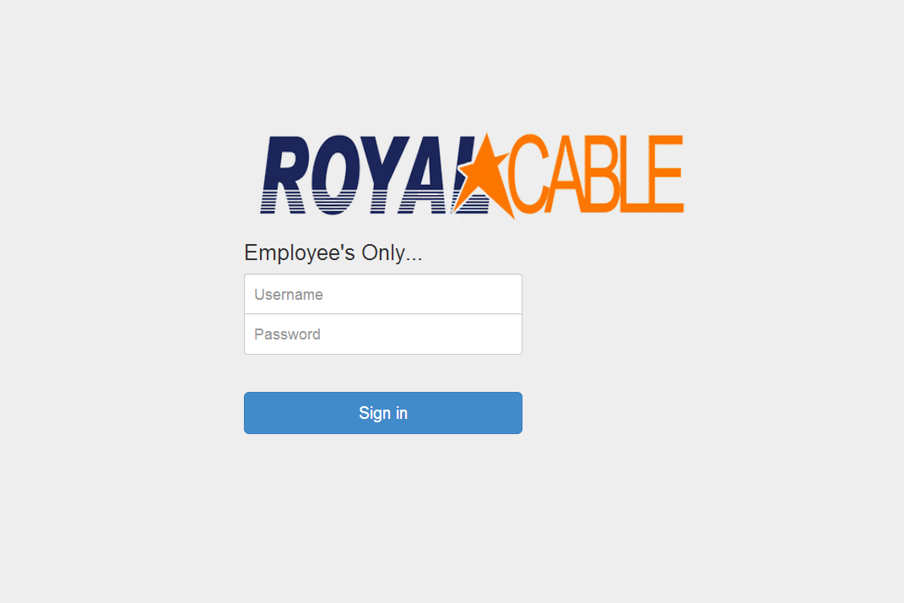

*Figure 4 – 7 Employee Login screen*

File Name: EmpSign.php

Description: This is where the Employee will log into the system. Only the Employees that have been approved by the IT Administrator can log in. This webpage includes the follow files to work;

* admlogin.php – This file will check if the username and password is present in the Database.

Screen Name: 1.1 Employee Control Panel

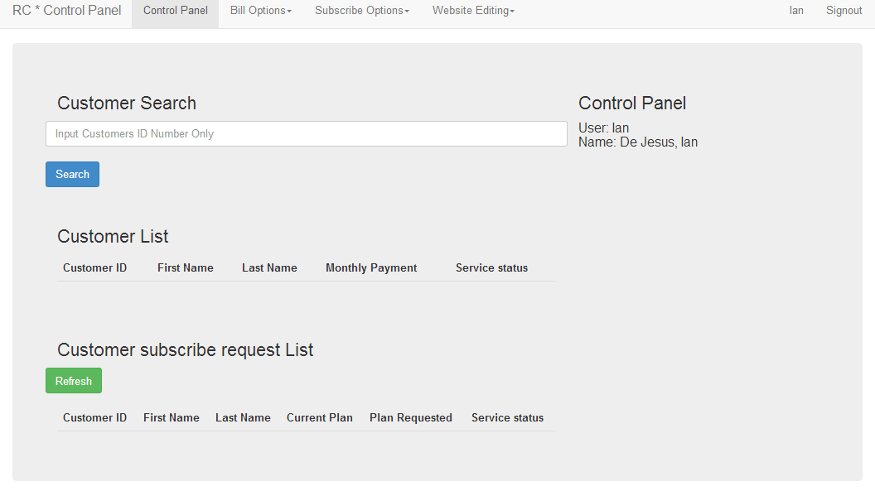*Figure 4 –8 Employee control panel page*

File Name: Controlpanel.php

Description: This the control plan of the employee. The search bar represents as the terminal for employees to find their customers and conduct any of the CRUD functions for billing information, customer information or editing the website. Employees will be able to search for new customers to register. This webpage includes the follow files to work and make it dynamic;

* require 'search.php'; This file will search for any of the customers that have a particular ID. This will only display the customer. Other search bar may have modifications to suit the Web page’s use.

Screen Name: 1.2 Adding Bills

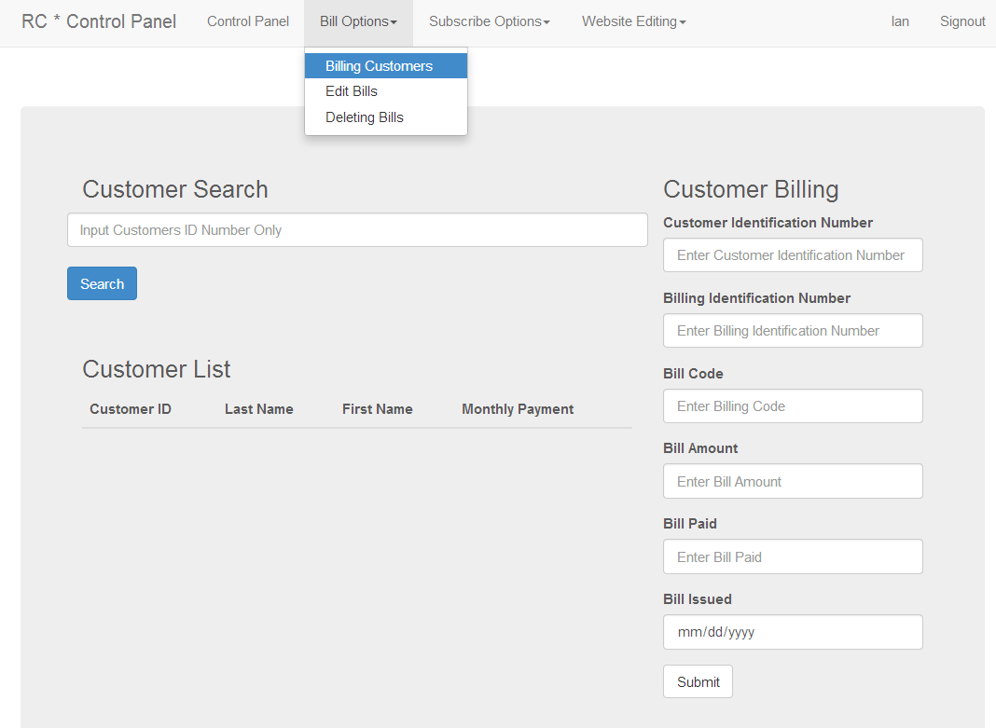

*Figure 4 –9 Employee Billing Panel Page*

File Name: billing.php

Description:

This webpage will allow the employee to insert new bills. The customer Identification number is required in order to submit the bill for a particular customer. The search bar acts as reference for employees to search for their customers in the system. This webpage includes the follow files to work and make it dynamic;

* require 'editSearch.php'; - This file will search a particular customer’s information and output the Customer info as well their billing information.
* bill.php – This file contains the commands for the Employee to add new Bills to a particular Customer. The Customer Id and the Billing ID must unique.

Screen Name: 1.3 Editing Bills

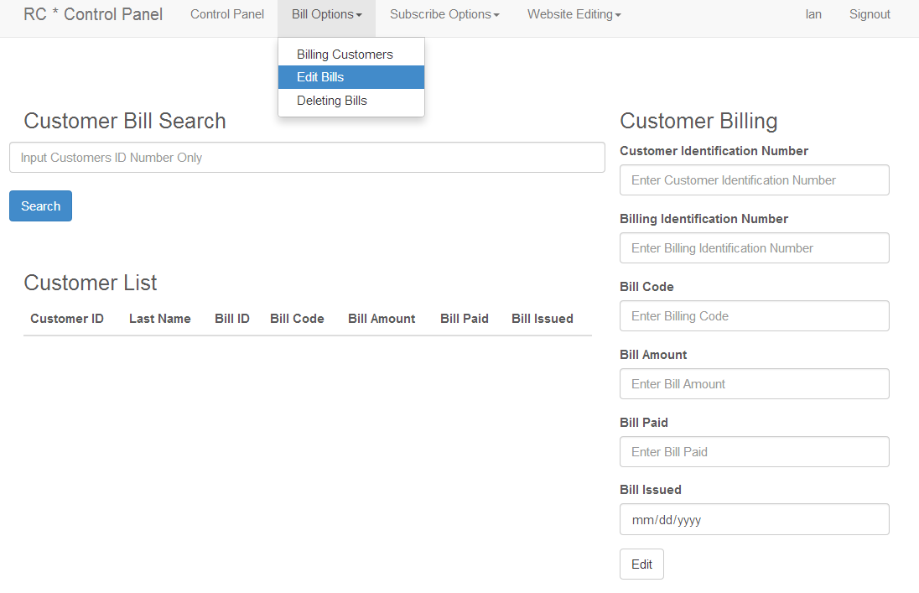

*Figure 4 –10 Employee Bill Editing Panel Page*

File Name: editing.php

Description:

This webpage lets the employee edit bills. IF an employee cannot remember the customer’s Identification number, the search bar is available at the employee’s convenience. This webpage includes the follow files to work and make it dynamic;

* require 'editSearch.php'; - look at Screen Name 1.2 Adding Bills for details
* editTrial.php; - This file contains the commands for the employee to edit any bill. Although, the Employee must input the Customer ID and the Billing ID in order to edit.

Screen Name: 1.4 Deleting Bills

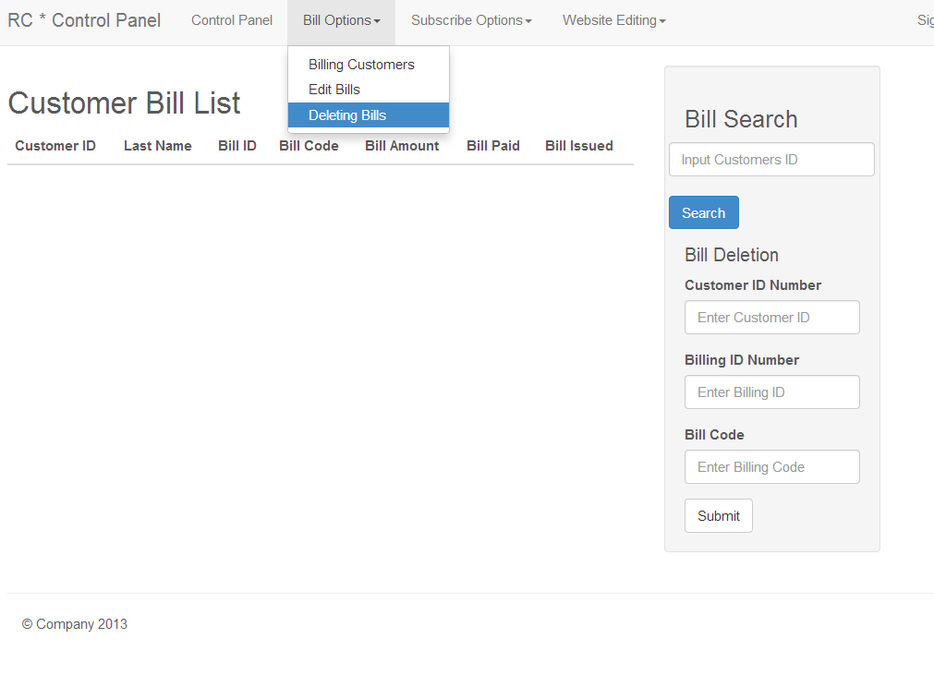

*Figure 4 –11 Employee Bill Deleting Panel Page*

File Name: deleting.php

Description:

This web page allows the employees to delete bills so that when it shows up in the customers billing history, they are not congested with the billing information. The customer ID and the Billing ID are required in order to delete the bill. This webpage includes the follow files to work and make it dynamic;

* require 'editSearch.php'; look at Screen Name 1.2 Adding Bills for details
* deleting.php; - This file contains the commands for employees to delete bills. This web page will require you fill out the entire form in order for a bill to be deleted.

Screen Name: 1.5 Editing Customer Information & Subscription

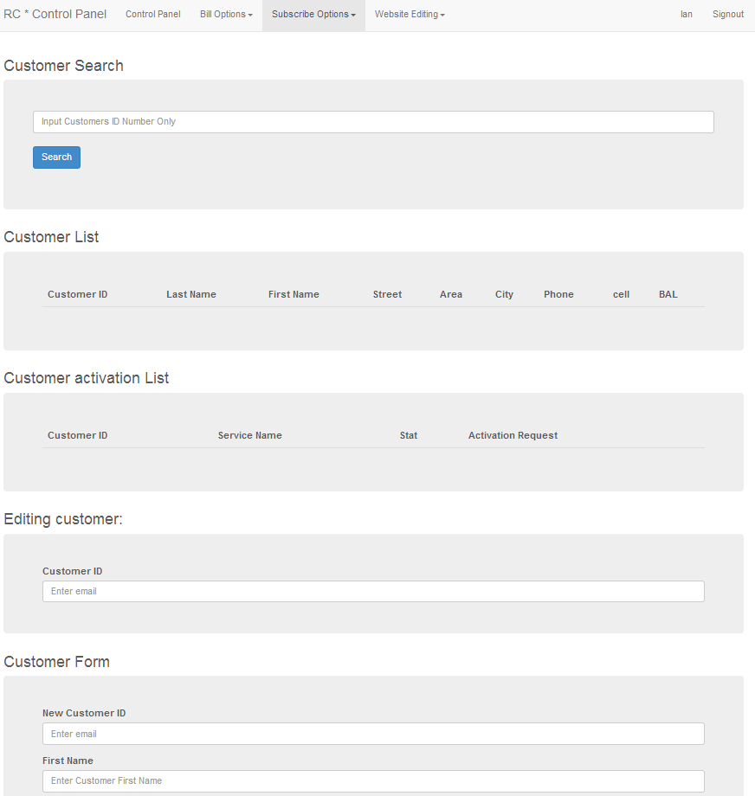*Figure 4 –12 Employee Customer Editing Panel Page*

File Name: editingCust.php

Description:

This web page allows the employees to change any information pertaining to the customer. The employee however is required to insert the customer’s ID. This webpage includes the follow files to work and make it dynamic;

* require 'custSearch.php'; - This file will allow the employees to search for the a customer Details the services that they are associated with.
* include 'dropInfo.php'; - this file is a quick access of data for only the services.
* customerEDIT.php; - This file contains the commands for the employee to edit the customers information and subscription details. Only the Customer ID is required, and the employee has the option to select one or multiple forms to fill out for editing.

Screen Name: 1.6 Deleting Customer Information

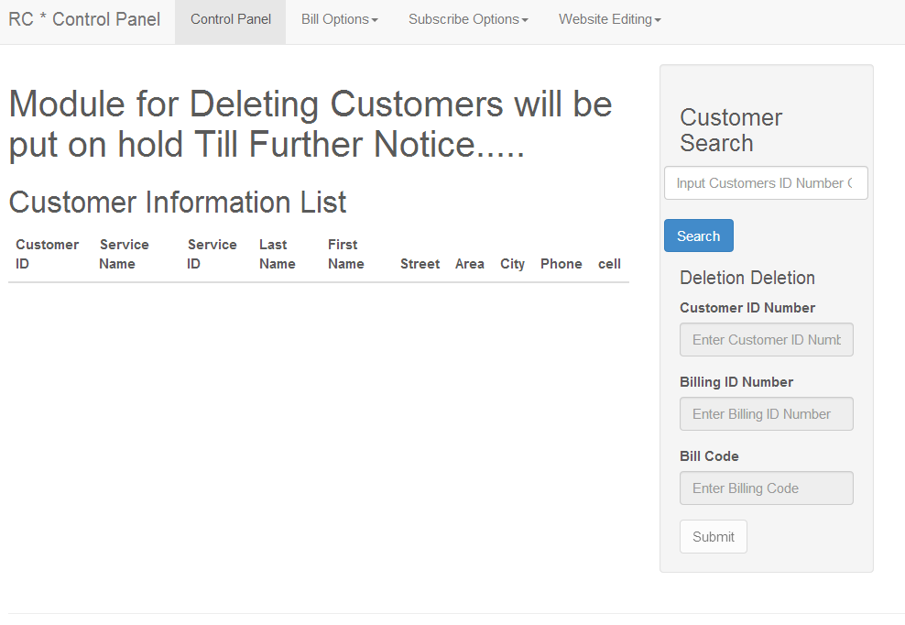*Figure 4 –13 Employee Customer Deleting Panel Page*

File Name: deletingCustomer.php

Description:

This webpage allows the employees to delete a particular customer from the system. However, this module is suspended until approved by the operations management. This webpage includes the follow files to work and make it dynamic;

* include 'custSearch.php'; - look at Screen Name 1.5 Editing Customer Information & Subscription for details
* custDelete.php; - This file allows the employee to delete a user from the system. *Note that this web page was put on hold until the IT department has made a decision to put it back on.

Screen Name: 1.7 Editing the Subscription Prices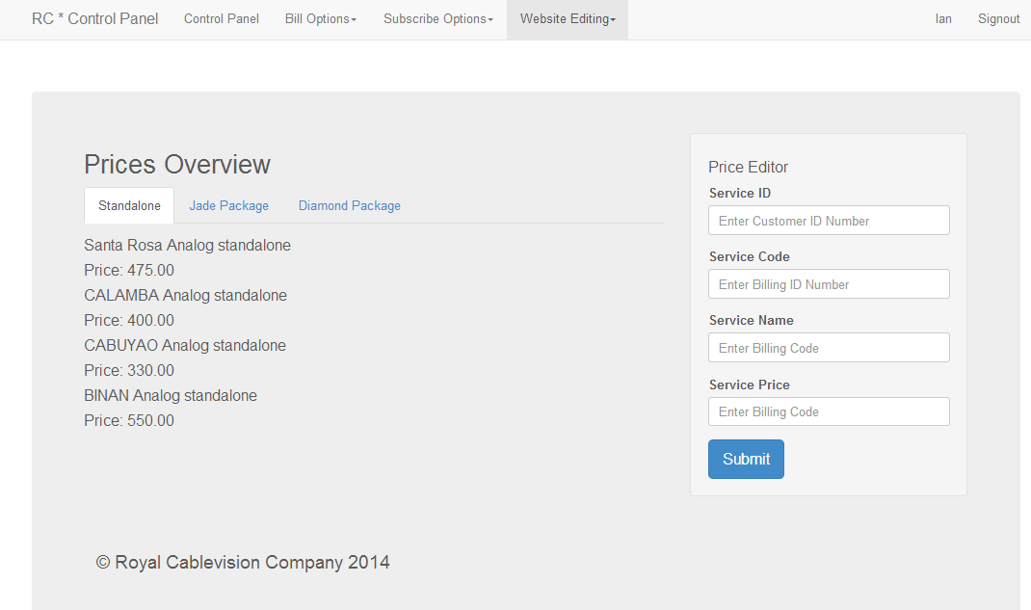*Figure 4 –14 Employee Price Editing Panel Page*

File Name: EditSubscribe.php

Description:

This web page allows employees to edit the prices of the particular plans that Royal Cablevision provides. The Site ID and the Site Code is required in order to work. This webpage includes the follow files to work and make it dynamic;

* include 'PriceLocate.php'; - this file contains queries to select all the prices from the DB.
* editService.php – this file will allow the employee to edit the prices of the packages. The prices will be updated throughout the System and the website.

Screen Name: 1.8 Website Editing Control Panel

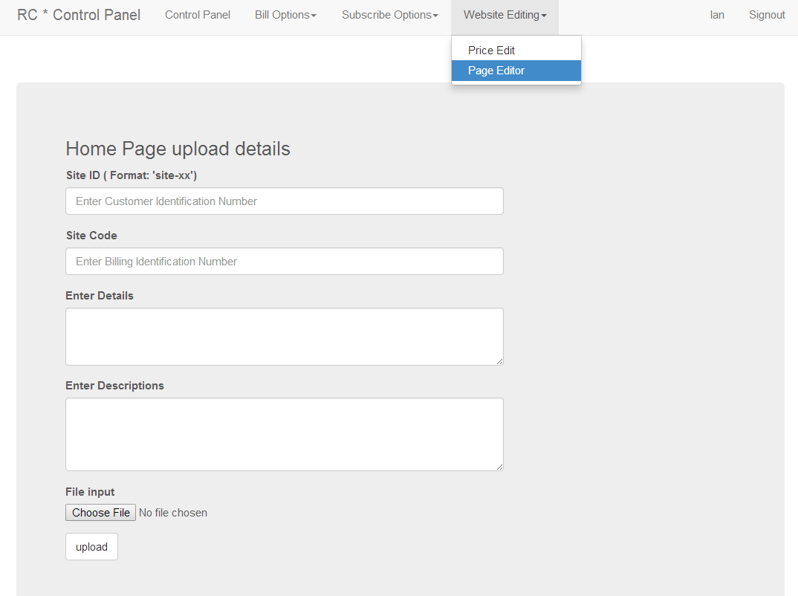*Figure 4 –15 Employee Page Editing Panel Page*

File Name: controlHome.php

Description:

This web page allows employees to edit the prices of the particular plan that Royal Cablevision provides. The Site ID and the Site Code is required in order to work. Due to some difficulties with the setting of the images and the Database, uploading pictures was postponed till further notice. This webpage includes the follow files to work and make it dynamic;

* upload.php This file is design to edit the web pages of Royal Cable Official Website.
  + 1. **Screen Specifications: Royal Cablevision Website**

Screen Name: 2.0 Homepage

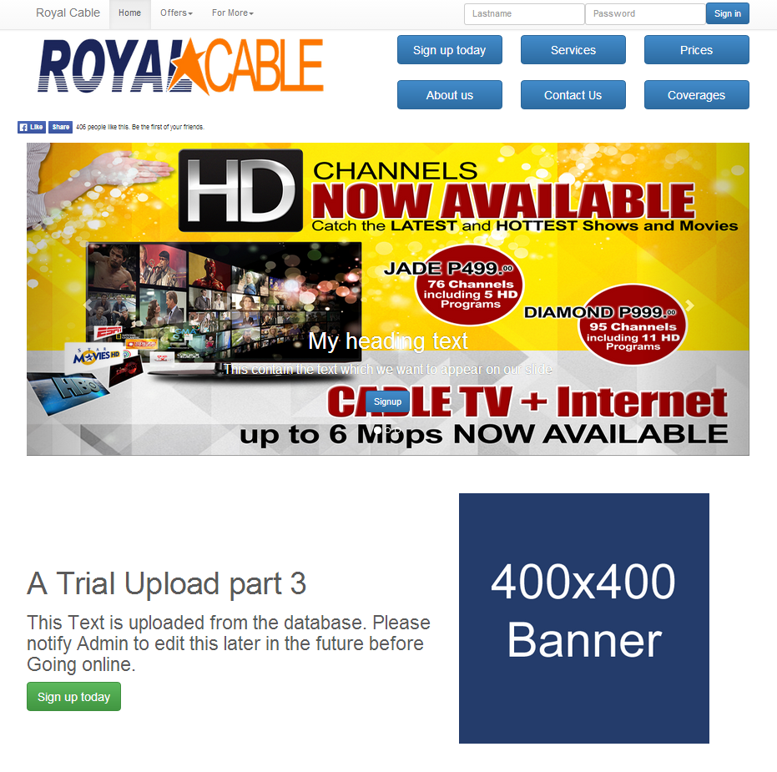*Figure 4 –16 Royal Cablevision Home Page*

File Name: Index.php

Description:

This webpage is the Home page to Royal Cablevision. This page contains the navigation bar which is fixed through the site. This webpage includes the follow files to work and make it dynamic;

* include 'site1.php'; this file contains the instruction for the web page to be updatable.

Screen Name: 2.1 subscribe

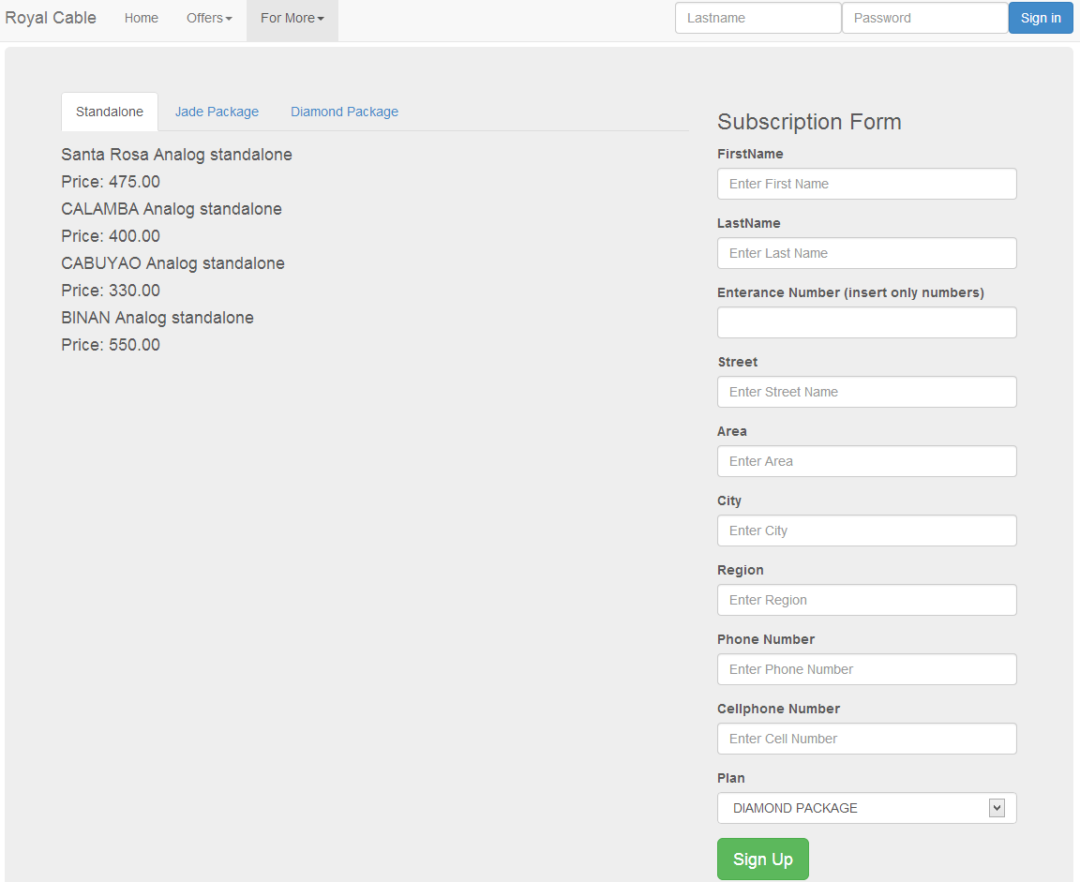*Figure 4 –17 Royal Cablevision Subscription Page*

File Name: subscribe.php

Description:

This page allows non-subscribers to subscribe to Royal Cablevision. A customer will provide a temporary numeric ID for the employee to find and edit themselves into the system. This process was requested by the IT department. This page contains the navbar which is fixed through the site. This webpage includes the follow files to work and make it dynamic;

* include 'PriceLocate.php'; - this file contains queries to select all the prices from the DB
* CustomerAdd.php - This file contains the commands for the customer to subscribe to a particular plan.

Screen Name: 2.2 Prices & Packages

**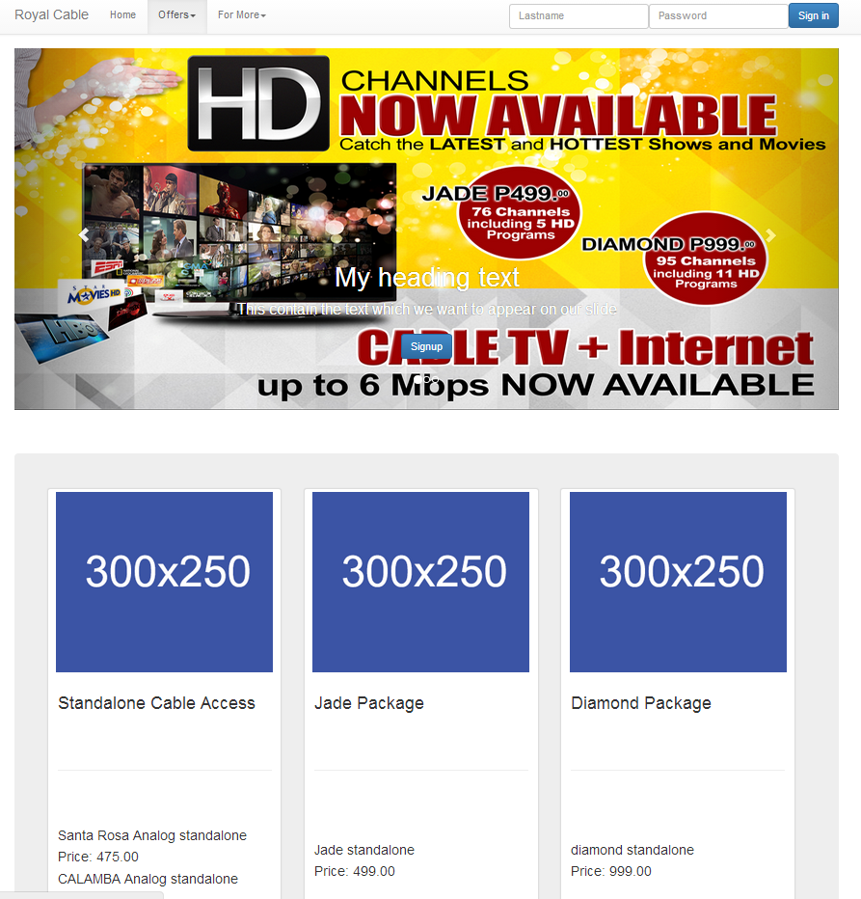***Figure 4 –18 Royal Cablevision Prices & Packages Page*

File Name: prices.php

Description: This Webpage allows the customer to view the latest Plans of Royal Cable vision has to offer. A plans are updated through the Accounting Information System and will subject to change without notice. There are buttons at the bottom of the sit if the user is ready to acquire a package they desire. This webpage includes the follow files to work and make it dynamic;

* include 'PriceLocate.php'; - this file contains queries to select all the prices from the DB.

Screen Name: 2.3 Services & Promotions

**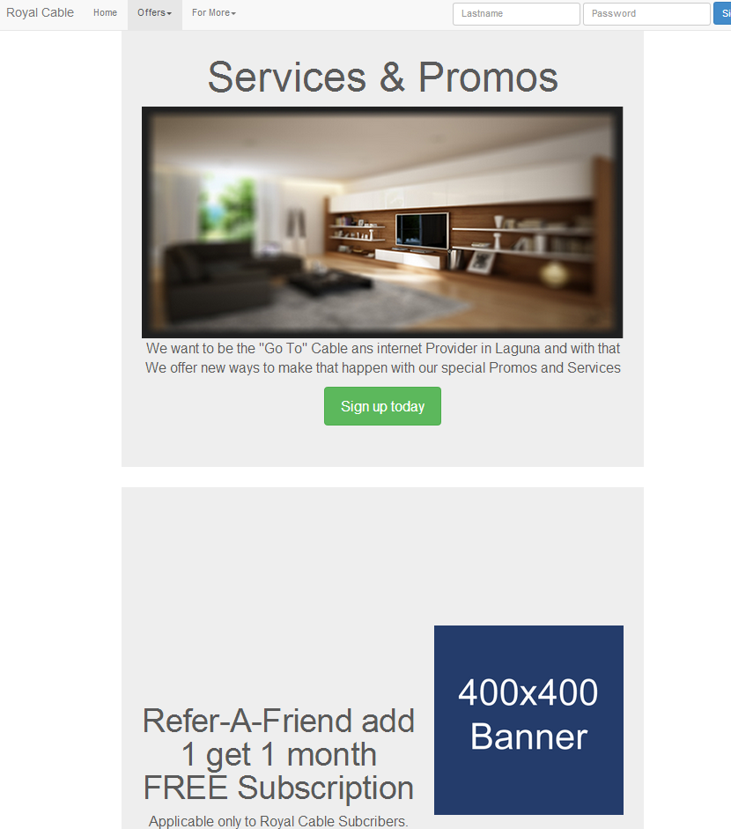***Figure 4 –19 Royal Cablevision Services and Promo Page*

File Name: Services.php

Description: This web page allows the customer to look at the promotions and services that Royal Cablevision provides. The green button the found in the middle of the webpage directs the customer to the subscription page. This page contains the navigation Bar which is fixed through the site. This webpage includes the follow files to work and make it dynamic;

* include 'site2.php'; - this file contains queries to select all the prices from the Database.

Screen Name: 2.4 Coverage

**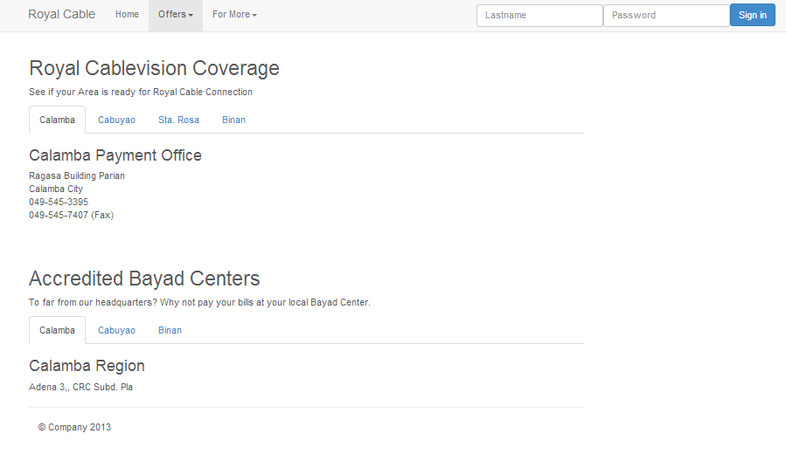***Figure 4 –20 Royal Cablevision Coverage Page*

File Name: coverage.php

Description: This page show the customers where the offices are located. As of 3/26/2014, the Locations of where subscribers can pay their bills at their local Bayad center was brought down for evaluation.

Screen Name: 2.5 Contact Us

**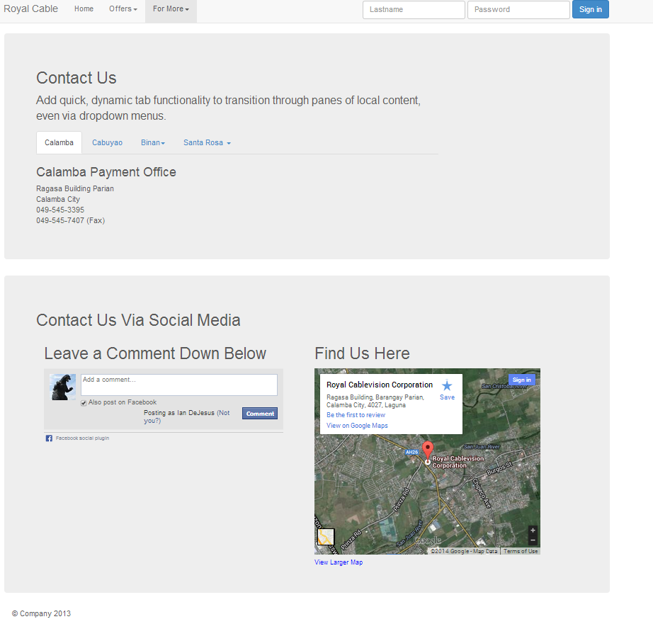***Figure 4 –21 Royal Cablevision Contact Us Page*

File Name: contactUs.php

Description:

This web page contains Royal Cablevision’s Contact information. There is also a comment portal for those who have a Facebook account and can leave a comment raising their concerns to the company.

Screen Name: 2.6 About US

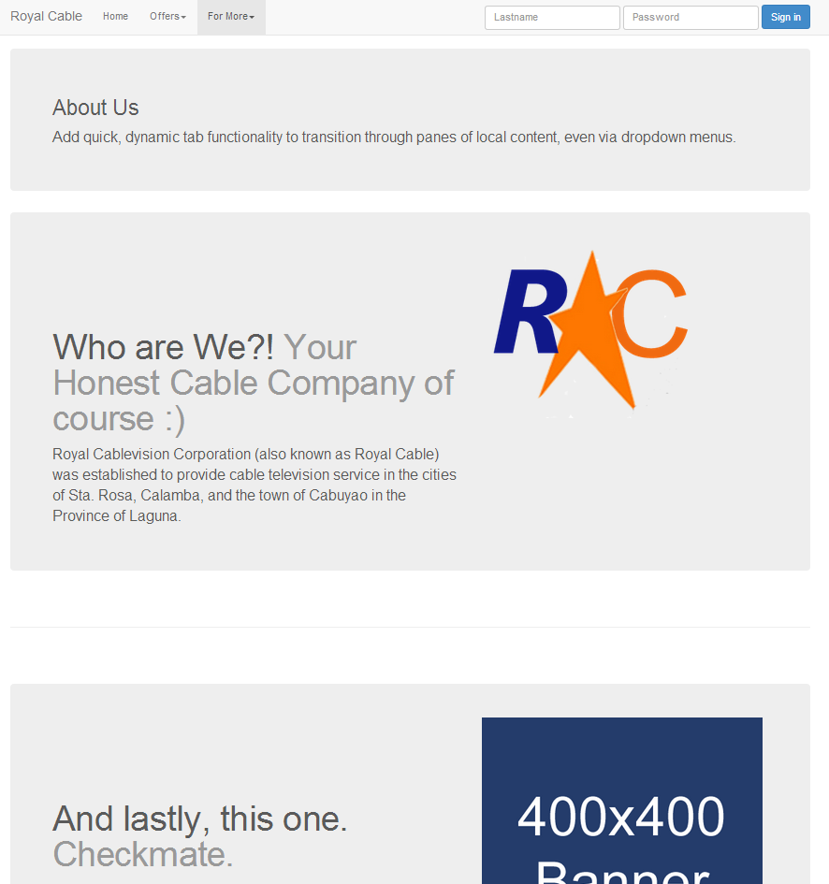*Figure 4 –22 Royal Cablevision About Us Page*

File Name: About.php

Description: This web page shows all the customers, the company background, what the company stands for, and what the Company believes in.

Screen Name: 2.7 Customer Balance

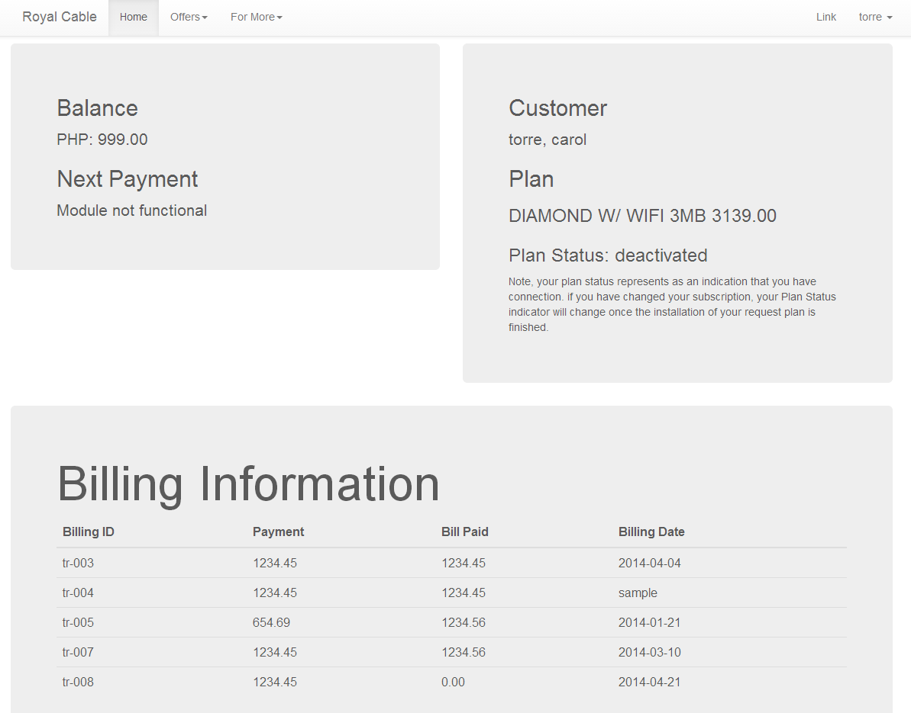*Figure 4 –23 Royal Cablevision Balance Page*

File Name: balance.php

Description: This web page shows all the customers billing information and their billing history. Every customer will be able to view their outstanding balance or the amount of money that they need to pay. This also includes the Customer’s subscription details.

* include 'user.php';

Screen Name: 2.9 Customer Account Change

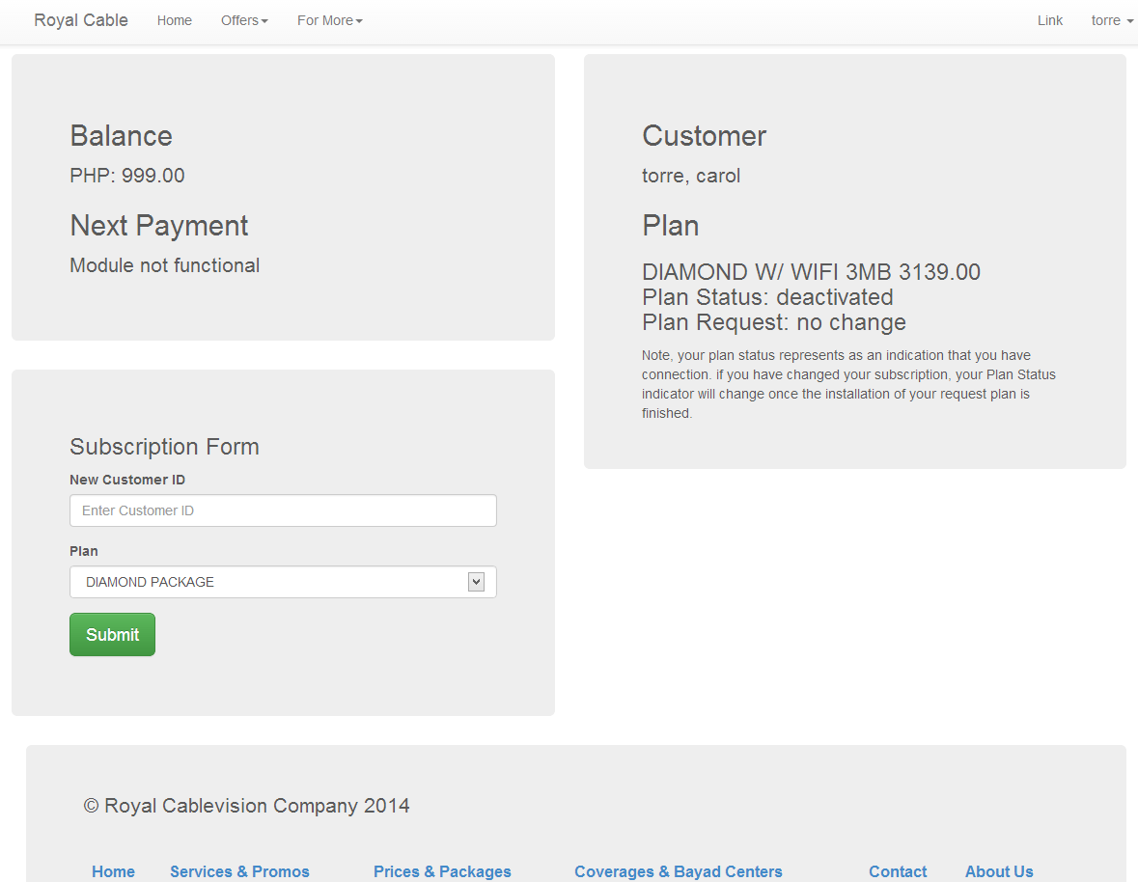*Figure 4 –24 Royal Cablevision Customer Account Change Page*

File Name: accountChange.php

Description: This web page shows all the customers the ability to change their subscription plan. Every customer will be able to change their change their subscription. The customer will receive information about change their plans once the company approves their request. According to Royal Cablevision, this page is still in review. This also includes the Customer’s subscription details.

* include 'user.php';
  + 1. Form Specifications

|  |  |  |
| --- | --- | --- |
| **Form Name** | **Description** | **Used By** |
| Admlogin | A form where employees must enter their log-in details in order to gain access to the AIS Web Application. | Administrator, Employees |
| Bill | A form that accepts the billing information from the Employee for creating new bills. | Administrator, Employees |
| editTrial | A form that accepts the billing information from the Employee for updating bills assigned to a customer. | Administrator, Employees |
| Deleting | A form that allows the Admin or the employee to select and delete customer bills. | Administrator, Employees |
| editingCust | A form where employees can update customer information and Customer subscription details. | Administrator, Employees |
| custDelete | A form that that will delete a customer from the Database. Deleting any billing or subscription information pertaining to that customer. | Administrator, Employees |
| editService | A form that allows an Admin or Employee to update prices or the subscriptions. | Administrator, Employees |
| Upload | A form that allows the employee of the admin to upload information to a particular webpage. | Administrator, Employees |
| editSearch, search, custSearch | A form that allows an Admin or Employee to search for a particular Customer, or bill | Administrator, Employees |
| Login | A form that allows the subscriber to login to the website. | customer |
| CustomerAdd | A form that allows the customer to subscribe to Royal Cablevision. | customer |

*Table 4 – 4 Form Name Description for the Web Application*

* + 1. System Coding

<!--Bootstrap Style Sheets-->

<link rel="stylesheet" type="text/css" href="css/bootstrap.css" />

<link rel="stylesheet" type="text/css" href="css/bootstrap-responsive.css" />

<link rel="stylesheet" type="text/css" href="css/bootstrap-theme.css" />

<!--Custom Style Sheets-->

<link href="css/carousel.css" rel="stylesheet">

<link href="css/offcanvas.css" rel="stylesheet">

<link href="css/jumbotron-narrow.css" rel="stylesheet">

<link href="css/signin.css" rel="stylesheet">

<link href="css/featurette.css" rel="stylesheet">

*Figure 4 –25 Bootstrap CSS code*

The intern insisted to use an Open Source styling framework called Bootstrap as part of the Accounting Information System and Royal Cablevision Website. This use of the framework will employees of the IT Department an effective way to edit the style of the code. With Bootstrap’s easy and ready to manipulate classes, the employees only effort is understand how each class works place it in the html code.

<!—Facebook Like and Share Div Tag-->

<div class="fb-like" data-href="https://www.facebook.com/pages/Royal-Cablevision-Corporation/157749950930100" data-layout="standard" data-action="like" data-show-faces="true" data-share="true"></div>

<!—FB script tag for the Like and Share Div -->

<script>(function(d, s, id) {

var js, fjs = d.getElementsByTagName(s)[0];

if (d.getElementById(id)) return;

js = d.createElement(s); js.id = id;

js.src = "//connect.facebook.net/en_US/all.js#xfbml=1";

fjs.parentNode.insertBefore(js, fjs);

}(document, 'script', 'facebook-jssdk')); </script>

*Figure 4 –26 Facebook ‘Like’ and ‘Share’ div Snippet*

Facebook Develop tags for the like and comment button.

<!—Facebook Like and Share Div Tag-->

div class="fb-comments" data-href="https://www.facebook.com/pages/Royal-Cablevision-Corporation/157749950930100" data-width="450" data-numposts="5" data-colorscheme="light"></div> </div>

<!—FB script tagfor the Like and Share Div -->

<script>(function(d, s, id) {

var js, fjs = d.getElementsByTagName(s)[0];

if (d.getElementById(id)) return;

js = d.createElement(s); js.id = id;

js.src = "//connect.facebook.net/en_US/all.js#xfbml=1";

fjs.parentNode.insertBefore(js, fjs);

}(document, 'script', 'facebook-jssdk')); </script>

*Figure 4 –27 Facebook Comment Div Snippet*

The intern used Facebook snippets to further expand the Company’s reach. The use of snippets such as the Facebook’s like and share Div tags will increase the Company’s presence and the directory of how to subscribe. The div tag were found in 2 pages, the Home Page and the Contact Us page.

PHP code snippets

if (isset($_POST['information indicator'])){

$search = $_POST (the submitted indicator)

$query = mysql_query("

The Query where the requested ID will be searched

");

$count = mysql_num_rows($query);

if ($count == 0){$output = 'there was no search results';}else{while ( $row = mysql_fetch_array($query) ){

Selects the customer information such the customer name or billing info;

$output .=' ( the information selected from the query )</td>'; }}

*Figure 4 –28 PHP Code: Searching Method*

This how the intern created the search functions in the control panel for employees. The PHP snippets are in pseudo-code to generalize the search functions that were used. *$count = mysql_num_rows($query);* allows the employee to respond to having no results rather than uploading nothing.

$_POST [receive information POST from Forms];

$cust_f = mysql_query("

UPDATE the site table

SET details = ‘the information that you want to be seen on the website’;

WHERE [the site matches with the site you want to edit] or die(mysql_error());

Name of the data = mysql_real_escape_string($_FILES[get file name]);

The encrypted data = mysql_real_escape_string(file_get_contents($_FILES[get file content]));

Type of file= mysql_real_escape_string($_FILES[ get file type])or die(mysql_error());

Update query = mysql_query("

UPDATE site

SET the information you want to edit for the webpages

WHERE the site matches ")or die(mysql_error());

*Figure 4 –29 PHP Code: Web Page Editing Snippet*

In figure 4-22, the Intern design an Update implementation for the website editing control. The purpose of that is to allow the employee to only update any text, heading or pictures for a particular page. Without having a history of text or pictures congesting the Database. Plus, the process solves the issue employees uploading useless material and having the employees to remember the codes for each item.

session_start();

login =session( user attempt login);

if (isset( the search query finds user)) { /**if the user is logged in, the Setting is shown to the user **/

Display user name on the up-right hand corner of the screen to signify the user has logged in

}elseif (!isset($stud)){/**if the user isnt logged in, the login form will be shown**/

SHOW THE SIGNIN form at the top-right corner of the screen and upload the current webpage.

session_destroy();

}else{/**troubleshooting**/

This space if for the employees testing snippets for troubleshooting the the sessions.

session_destroy();

echo "session not work"; die(mysql_error());}

*Figure 4 –30 PHP Code: Customer Login Method*

The customer log-in form has two conditions; a sign form that allows customer to log-in, the log-in status of a customer. The intern thought it would be best for users who are logged into the system, to still roam the official website. This option is only temporary because the company is still trying to figure out what options to given customers. The intern still allowed logged in customer to access the subscription page. The php file is in a ‘require’ php command. That way, the log-in form function will search for that user to see if that user have or have not logged in yet.

* + 1. **Site Structure**



*Figure 4 –31 Site Structure: Accounting Information System*



*Figure 4 –32 Site Structure: Royal Cablevision*

* + 1. Unit Testing

Search = mysql_query("

Query search

") OR die(mysql_error());

$customer = mysql_fetch_array($cusSearch);

//If customer ID exists..execute the IF STATEMENT

if (isset(customer exists)){

Selects all the Billing identification DB

") OR die(mysql_error());

Bill = mysql_fetch_array(Search);

if (isset(Bill)) {

Selects all billing information

bills = mysql_query("

Insert the billing information that you have submitted

") OR die(mysql_error());

//Query inputs the pay's values into the database

pays = mysql_query("

Insert the the customer information and the billing information

") OR die(mysql_error());

*Figure 4 –33 retrieve data from a from filled by an employee*

This snippet will insert information from an employee. The all modules have a similar feature that if the data is submitted by the employee, the page will direct them to the page that they are on. If not, the employee will receive a notification that will force the employee to go back. The only way for the employee to check if this module works is to use the search bar and look for the bill. The search bar in every module is used as an indicator that the employee submitted the information correctly. If an error occurs with the code, a notification will pop up notifying the employee to go back.

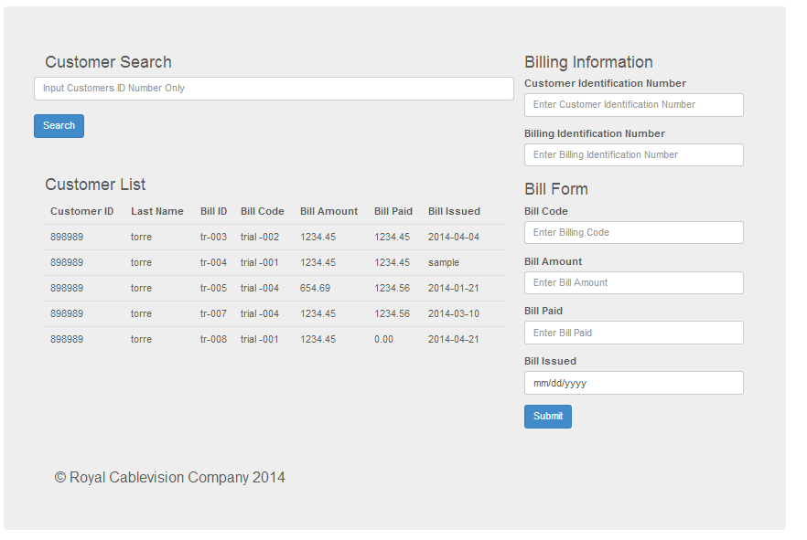*Figure 4 –34 Employee billing customers - searching for bills -*

The intern added several search options that allow employees to check if their submissions were inputted into the system correctly. Each search options contains different search properties that cater to what the employee wants to do. This option helps in the testing process. Once an employee fill out a form, they can check if the form exists in Database by searching the forms through the search modules.

In Figure 4 – 34, we can see that the employee is looking for a bill that they have already submitted. Although, all search modules are limited 1 or 2 key terms, the Customer’s Identification number and or the customer’s Last Name. Some search module differ depending on the options that are available to the employee.

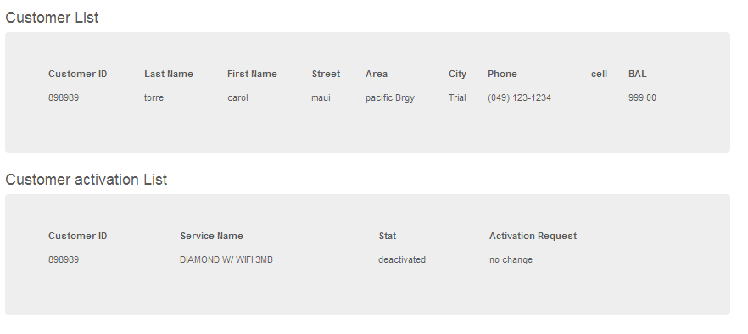*Figure 4 –35 Employee editing customers - searching for customers –*

In figure 4 – 35, the results of searching the customer is divided into categories; customer information and Customer Subscription activation. This lets employees access the customer details and if the customer’s plan has been activated. However, the customer activation list has a new feature. When customers want to change, there will be an indicator telling the employee to change the current plan to the new customer plan. Once the employee has updated the customer’s request, the activation request will be set to “no change”, and the information will be updated to the customer’s balance page.

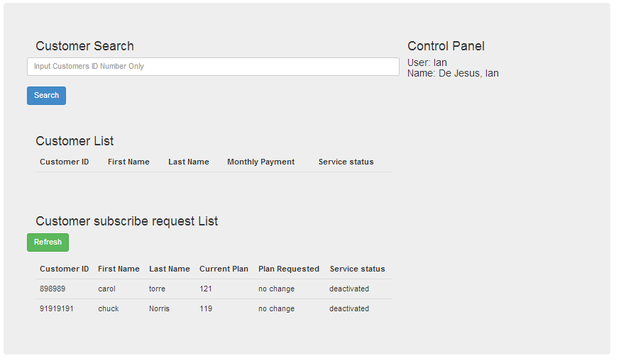*Figure 4 –36 Employee Control Panel – updating customers plan status –*

In Figure 4 -36, we see several customers who have changed their subscriptions. This Customer subscribe request list updates regularly to find customer who have changed their plans. This option serves as a notification module for employees to always update the customer’s request. This module is still in view from the company.

## Personnel Training

It is required that the acting IT Administrator or any of the IT staff to be familiar with the tools need to make any modifications to the code. The IT administrator must have an extensive knowledge with the scripting language, PHP. Since PHP will be the center piece to the web application, the administrator must also understand CRUD implementation and PHP commands alongside MySQL.

The administrator will need to skills to run Apache alongside MySQL DBMS. The Admin must also have a working knowledge with MySQL in order to manipulate data, migrate databases and archive any information. It is essential for the administrator to be familiar with SQL in order to make any changes to the Web Application.

The Administrator must have a working knowledge of JavaScript, jQuery or any script language required for bootstrap. There are references on how to the use JavaScript found in Bootstrap‘s website.

Lastly, the Admin must at least look at Bootstrap, for all the CSS codes are there to guide the Admin to edit the User Interface of the Website. The admin needs to under the classes that Bootstrap has already predefined in the CSS files.

# References

["Google Maps." *Google Maps*. Google, n.d. Web. 26 Mar. 2014. <https://www.google.com/maps/preview?source=newuser-ws>.](http://www.bibme.org/)

["MySQL :: The world's most popular open source database." *MySQL :: The world's most popular open source database*. Oracle Corporation, n.d. Web. 26 Mar. 2014. <http://www.mysql.com/>.](http://www.bibme.org/)

["PHP: Hypertext Preprocessor." *PHP: Hypertext Preprocessor*. The PHP Group, n.d. Web. 26 Mar. 2014. <http://www.php.net/>.](http://www.bibme.org/)

["Facebook Developers." *Facebook Developers*. Facebook, n.d. Web. 27 Mar. 2014. <https://developers.facebook.com/>.](http://www.bibme.org/)

[Lynch, Patrick J., and Sarah Horton. "3 Information ArchitectureSite Structure."*Site Structure*. Pair Networks, n.d. Web. 27 Mar. 2014. <http://webstyleguide.com/wsg3/3-information-architecture/3-site-structure.html>.](http://www.bibme.org/)

["HTML." *W3Schools Online Web Tutorials*. Refsnes Data, n.d. Web. 26 Mar. 2014. <http://www.w3schools.com/>.](http://www.bibme.org/)

Mendoza, Willy

IT Specialist in C#,

IT Department

Royal Cablevision

Buhay Jewel

Head of Marketing & Sale

Marketing & Department

Royal Cable Vision

buhayjewel@gmail.com/ 09399140060